From last 2.5 months there is no new backlog item added to D2ToC backlog.
We have already addressed this issue multiple times with business person
There is no such step taken to mitigate it or to reduce workforce.
- Alok asked me on mail regarding sprint retrospective but JB told not to reply the mail
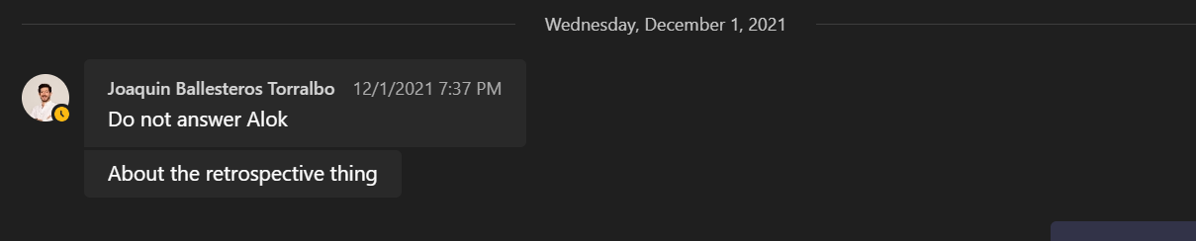

- Adding stories within sprint but after discussion with Matas, stories are not required for DTC
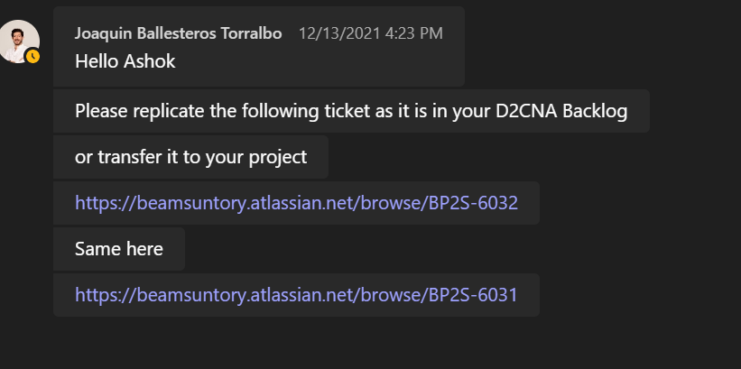
- Regarding D2C North America backlog meeting happened on 30th November, as per discussion with JB we have to discuss about our backlog but the conversation moved to other way where JB asking Matas about no description in current sprint stories.
- Task assigned to me by JB like Agile and DevOps Team
- Adding not productive stories just to have backlog
- In Last week of November, discussed about my goals with JB and told that you don’t need to fill that. But on last day 15th of December, I again reconfirmed with JB about performance document, at that time then he asked to fill it.

